- Pending Orders
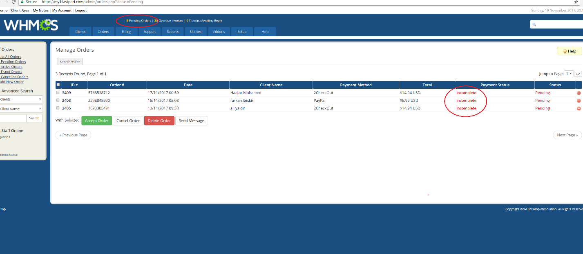

- Accept all orders that are green/complete
- Cancel all orders that are 6+ days old and in red/incomplete status

- Answer support tickets
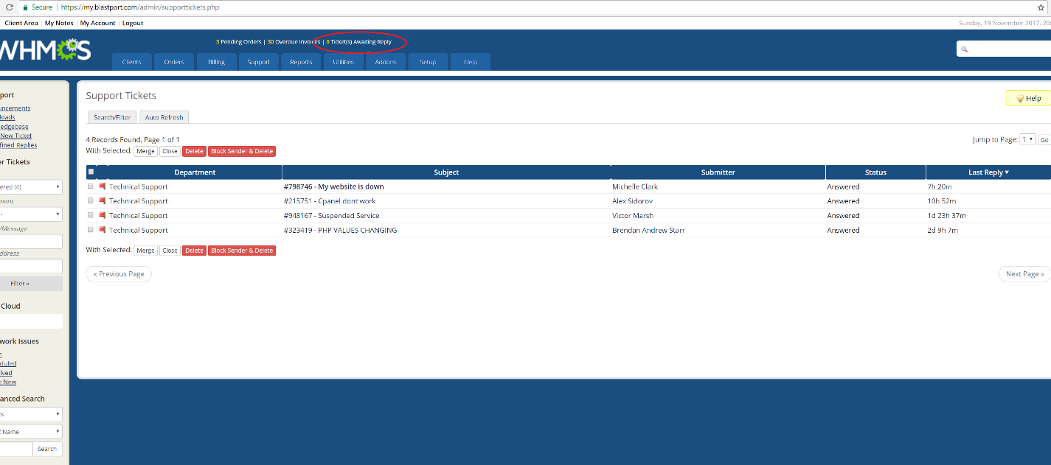

- Overdue invoices:

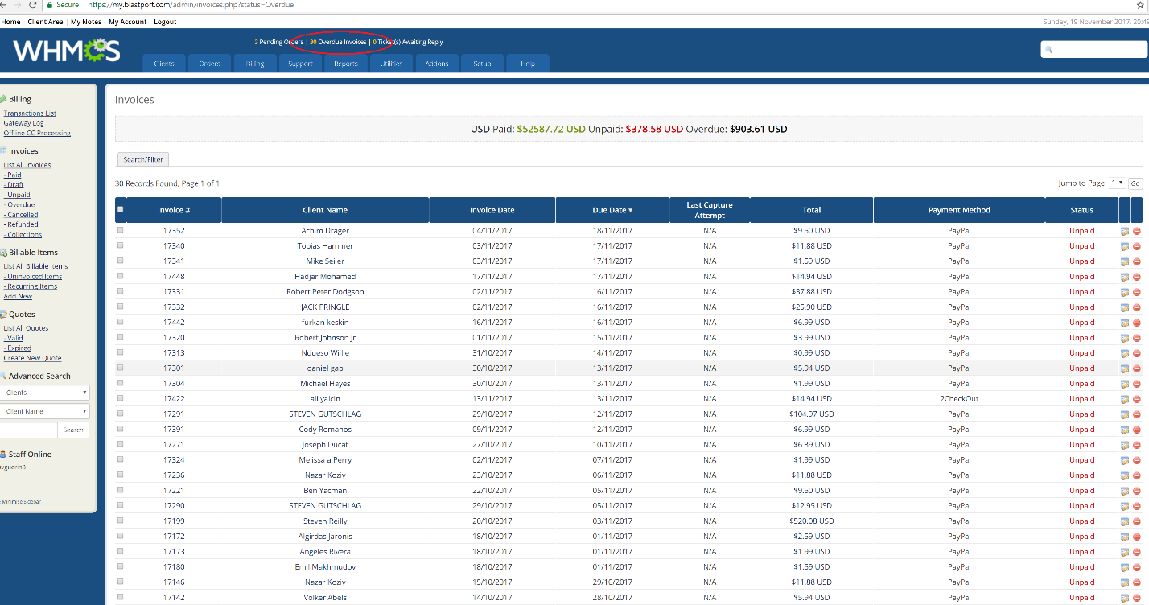

- See if there is a 3-day old customer who is overdue on invoice on an invoice for a package or domain invoice
- If there is 3 days old on sent an email for overdue invoice, then terminate the account

